Use the case below to answer questions 1 – 7 associated with this project
This is an actual event that occurred and was presented later in a competition. Names and other aspects were changed to protect all parties’ privacy. Use your standard template and record your answers in the appropriate section of the template.
The Case: Your boss John went to a BYOD conference lately. Yeah, he's that kind of security guy... After some mumble about targeted attacks happening during the event, your team finally got their hands on a PCAP with his traffic. Your colleague, Pete Galloway investigated the incident. Yesterday, he casually mentioned that he found some indication there were some “funny” things associated with some of the boss’s downloads and some weird Python bytecode, but he couldn't make much sense out of "random" payloads yet. Today, Pete didn't come to work. Five minutes ago, he sent a companywide mail with a total of four words: “F___ you, I quit.“.

Challenge: You are the forensic investigator. Your mission is to analyze the packet capture and gather information about what happened and why Pete was so upset and quit.

Answer the following questions using Wireshark and the VMWare Workstation (or you could use the Wireshark on your computer). You will first need to download the pcap file into the VMWare Workstation or your computer. The exam and pcap files are located in your BB in the Midterm exam tab.

- (5) (a) Capture a screenshot showing the Protocol Hierarchy for this file.
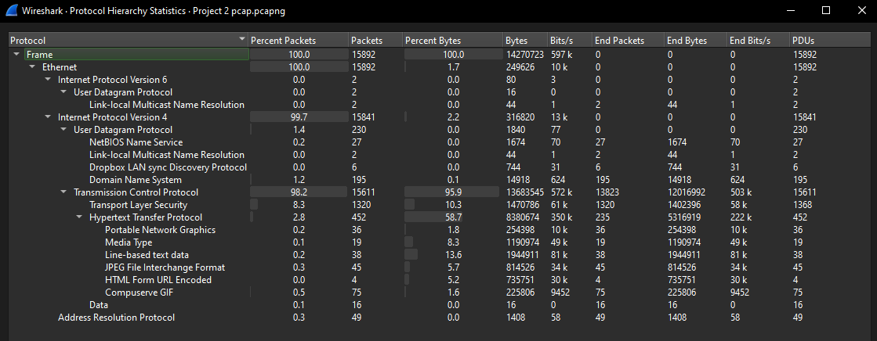
(b) What percentage of packets are TCP? What percentage of the TCP packets are HTTP?
TCP = 92.8% HTTP of TCP = 2.8%
- (9) You receive information that there may be a problem with individuals who try to access www.harveycartel.org within the DNS structure.
- Did your boss access this website?
Yes he did
- If so, what Frame numbers are related to this exchange?
Frame numbers 5668, 5669, 5671, 5672, and 5675 are related to the exchange.
- What is your boss’s IP Address and Port Number?
The boss’s IP address and Port Number are 172.16.254.128 and 56207 respectively.
- Approximately, how much time elapsed from the capture of Frame 1 to the Capture of Frame 15892 (Last Frame)? [Hint: Keep this in mind for later]
An approximate of 3 minutes and 11 seconds elapsed from the capture of Frame 1 to the capture of the last frame.
- Capture a screenshot of any relevant data.
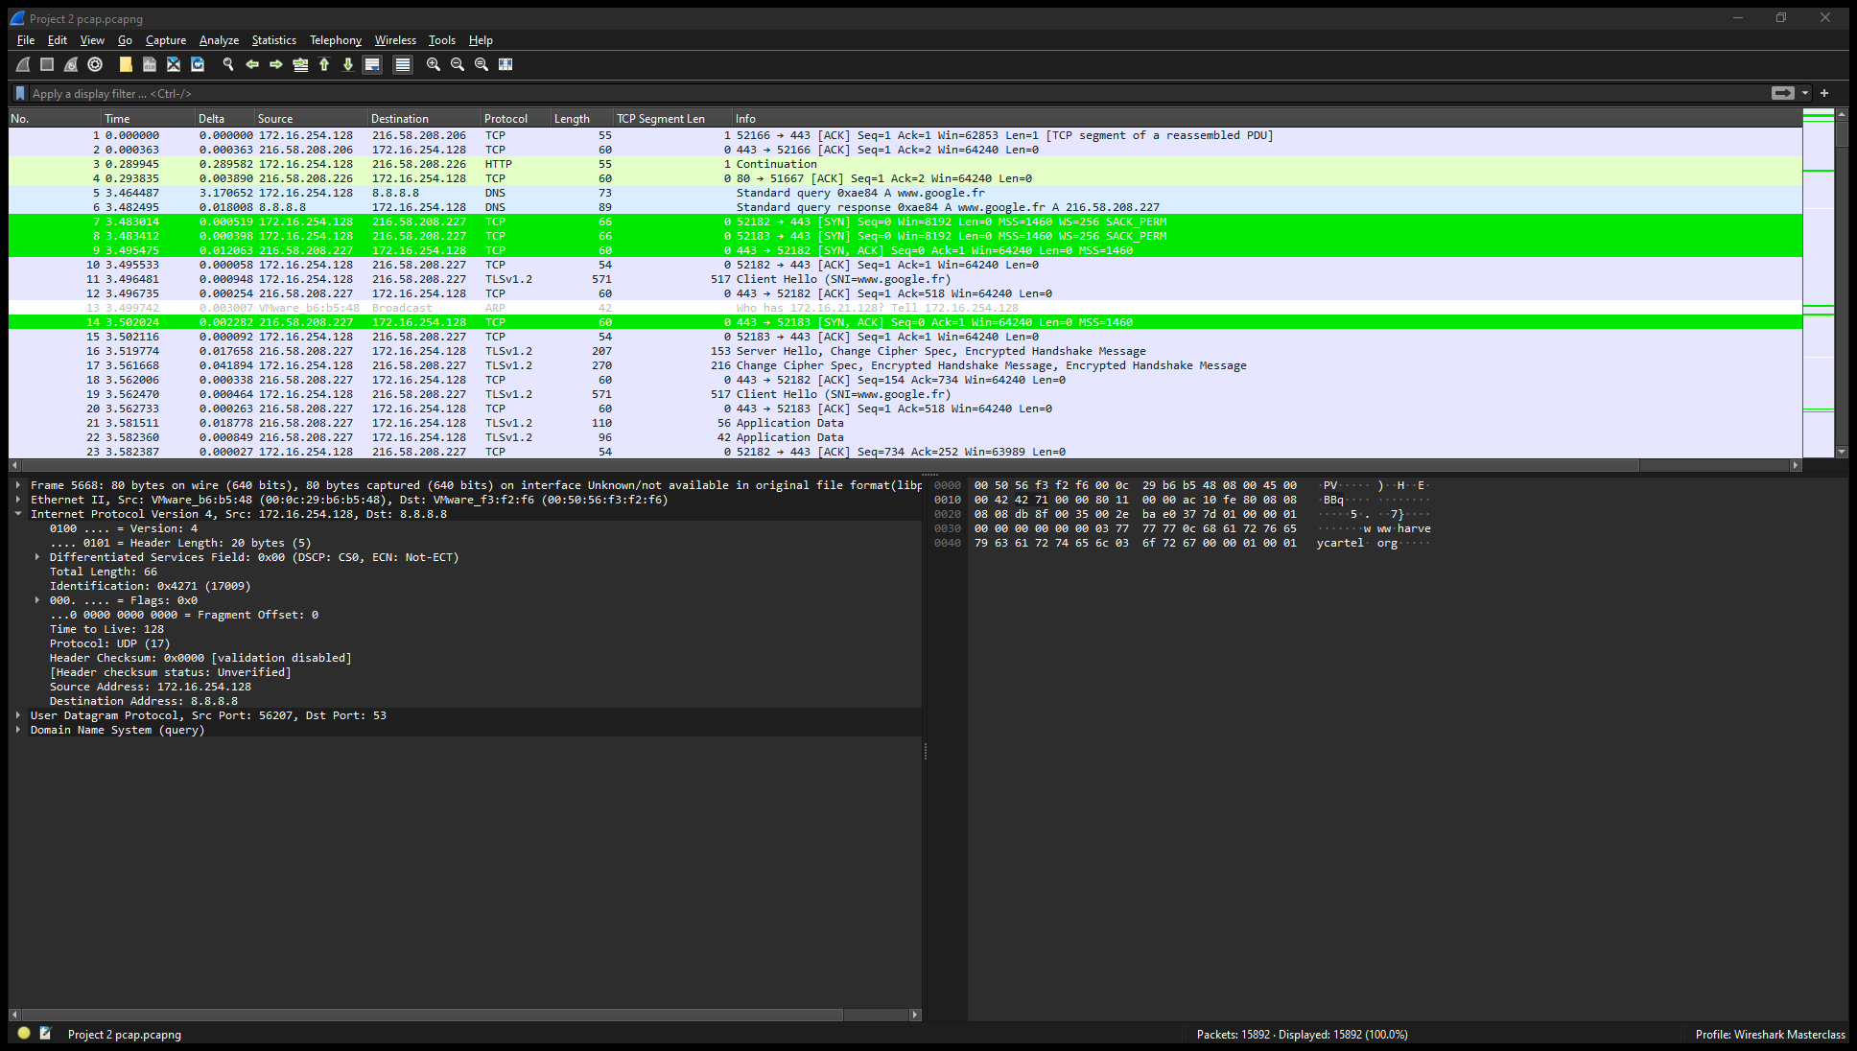
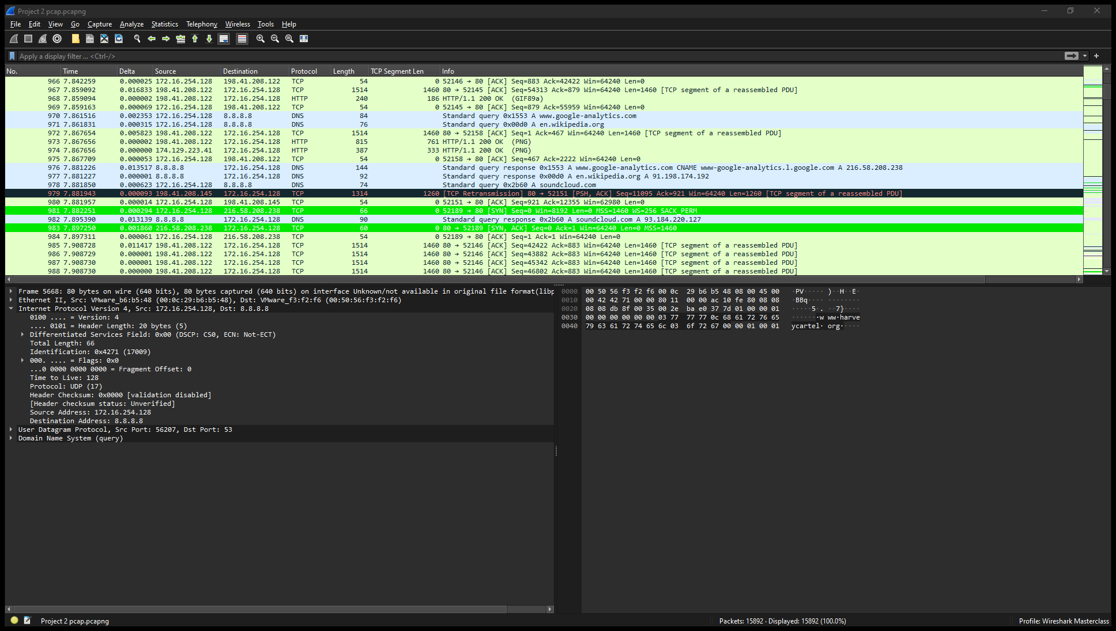
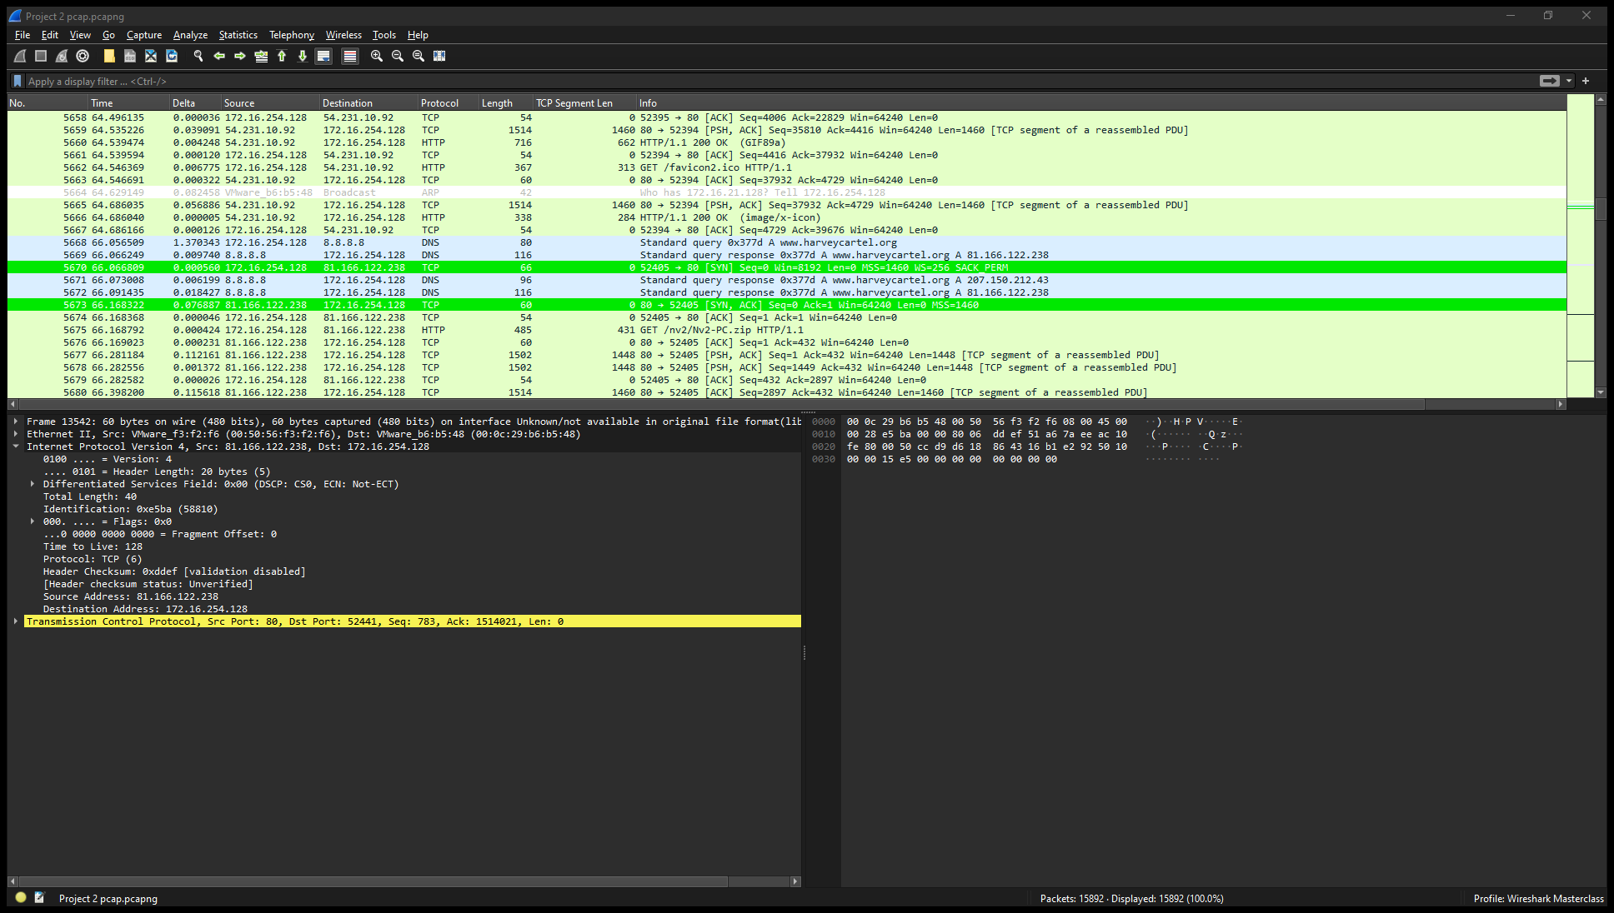
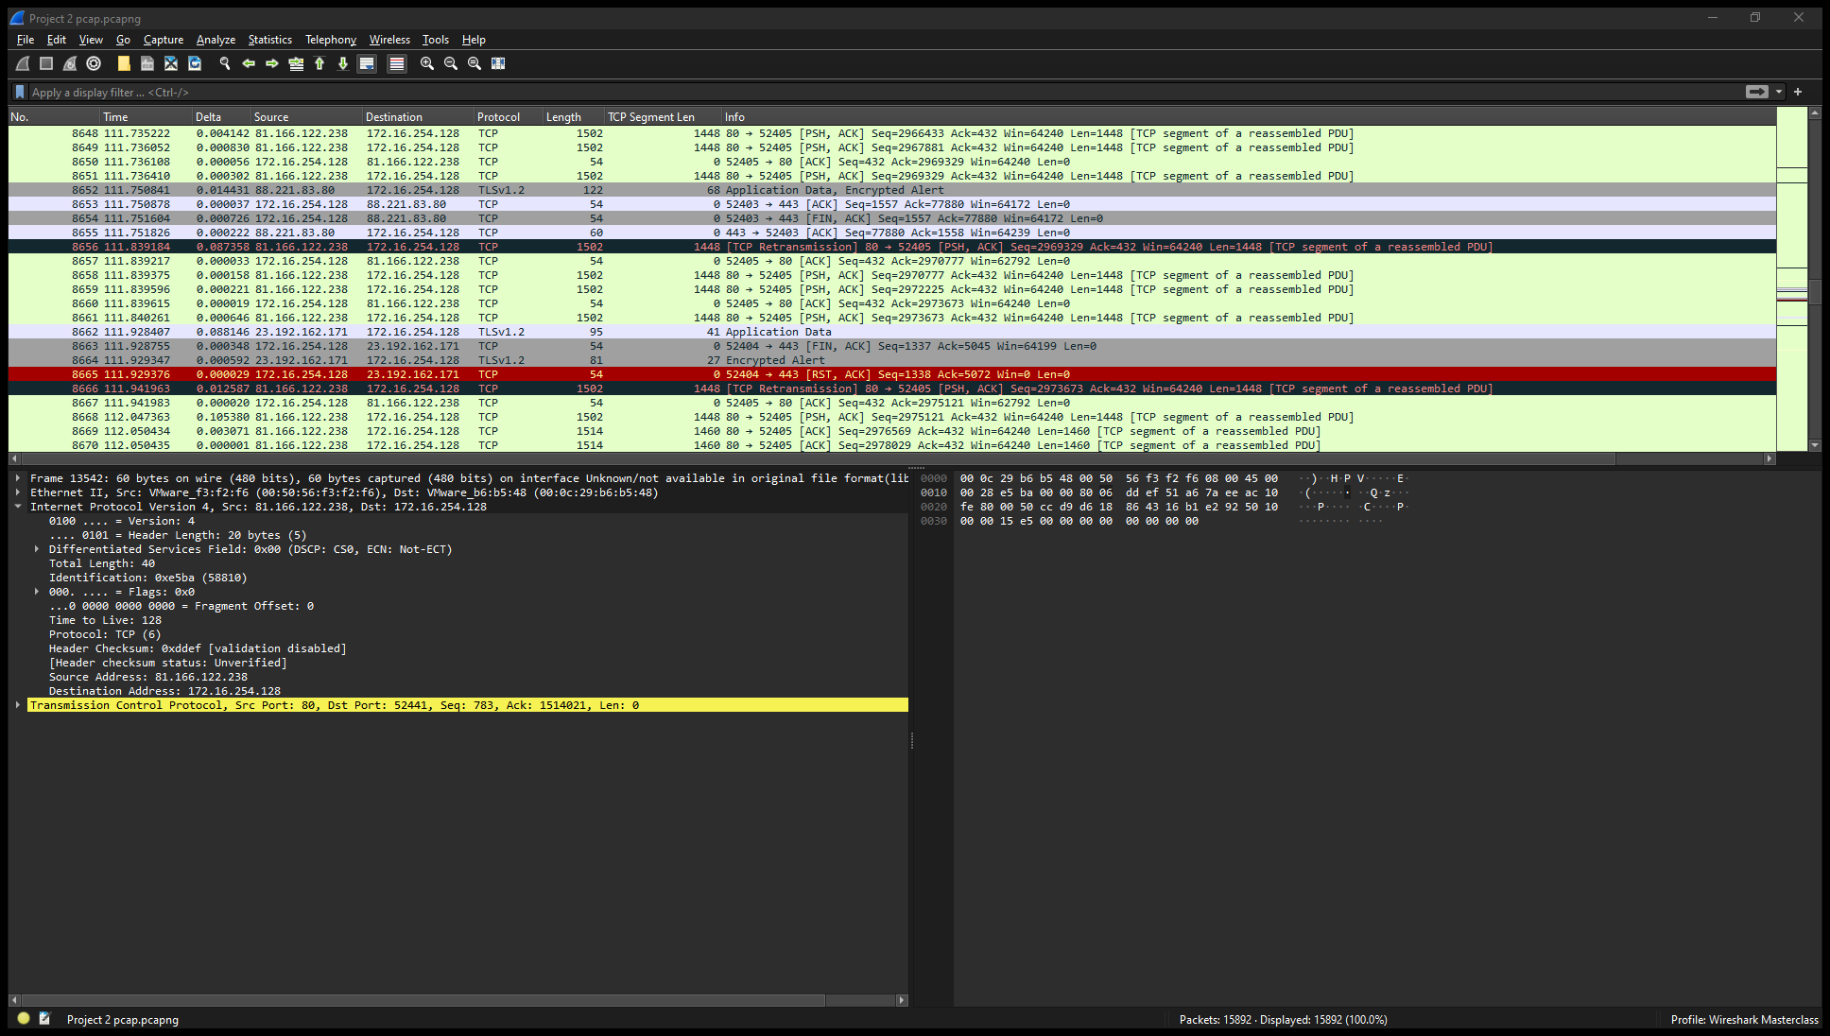
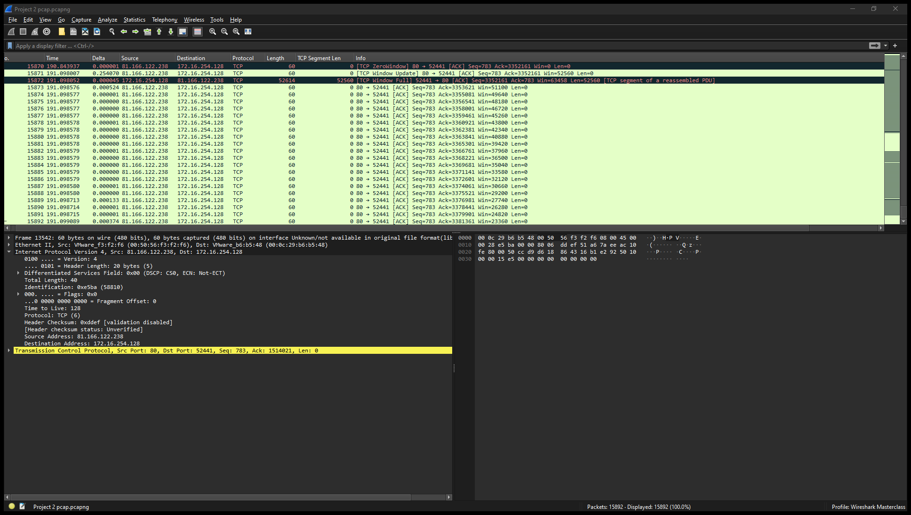

- (8) From prior experience, you know that the legitimate IP address for harveycartel.org is 207.150.212.43.
- What is the evidence showing?
Evidence indicates that the IP address which the boss has been accessing is not the actual harveycartel.org website.
- Can you explain what has happened?
It's likely that a hacker duplicated the website, and the version in the file doesn't have the correct IP address.
- Which response packets (use the frame#) are most likely nonlegitimate?
Frames 5670 till 10912 are most likely non-legitimate.
- What does the evidence most likely imply will happen when data are downloaded from a nonlegitimate site?
Files containing malware sourced from the rogue website pose a significant threat to the integrity of our firm's data. Once introduced into our system, these malicious files have the potential to corrupt, erase, or encrypt our valuable data, leading to severe disruptions and potentially irreversible damage. It's crucial to exercise extreme caution and implement robust security measures to prevent any unauthorized access to such harmful content.
- (8) (a) Identify the packets that include the exchanges with the nonlegitimate site. Open the HTTP packet associated with this IP address.
The packets that include exchanges with the nonlegitimate site include 5670 till 10912.
(b) In a classic case of cross-scripting, what is the URL source for the download of this file?
In the case of cross-scripting, the URL source for the download of the file is http://www.thewayoftheninja.org/n.html.
(c) Follow the stream and identify the filename of the downloaded file.
The filename for the downloaded file is Nv2-PC.exe
- Capture a screenshot of the Stream.
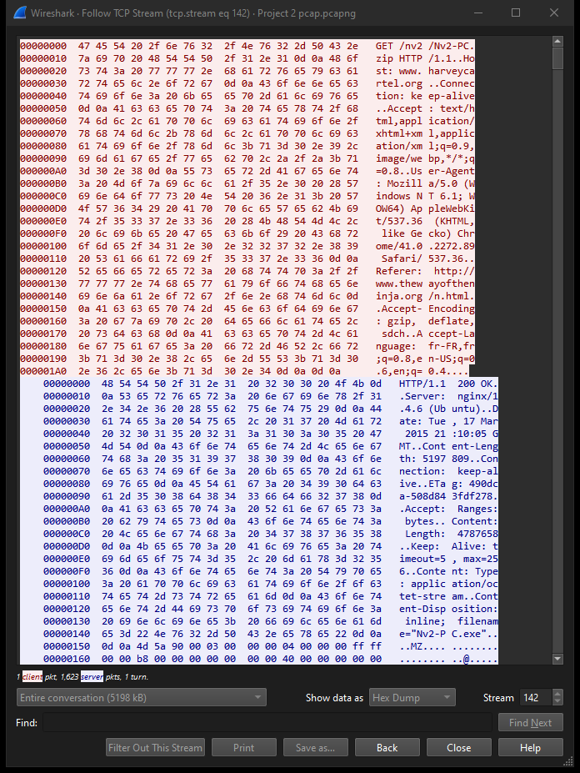
- (9) You also receive some intelligence that your boss may have purchased travel ticket(s).
- Can you confirm this?
Yes, I can confirm that my boss has purchased travel tickets.
- How?
To isolate the specific packet mentioned in 5(e), which is packet 11784, and analyze its contents using Wireshark, I utilized an IP filter set to my boss's IP address, 172.16.254.128. Within this packet, labeled as 11784, a document titled EmiratesETicket1.pdf is enclosed. This meticulous examination of the packet's content is essential for understanding the nature of the data being transmitted and ensuring the integrity of our network security.
- How many ticket(s) did he obtain?
He obtained a total of 2 travel tickets.
The first ticket can be found in packet 11784 and the document is named EmiratesETicket1.pdf .
The second ticket can be found in packet 12038 and the document is named EmiratesETicket2.pdf .
- What destination(s) is he planning for this trip?
He is planning a trip to Dubai.
- Capture a screenshot supporting your suspicions.
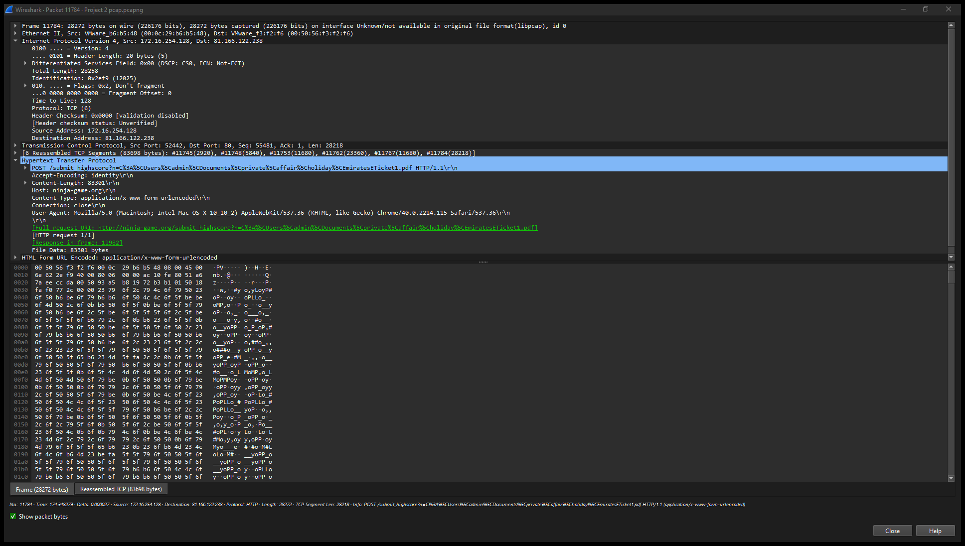
- (11) Your decryption team has identified and decrypted the attachment associated with packet #11745. They tell you that John Williams (your boss) is prominent in the attachment which has an execution date of April 01, 2015. The decryption team also decrypted packet #12038. They tell you that Sarah Galloway (Pete’s wife) is prominent in that attachment which also has an execution date of April 01, 2015.
- What is going on?
The analysis of the two packets provides compelling evidence suggesting that both John and Sarah are scheduled to travel to Dubai concurrently, sharing the same departure time and date. Such synchronization in their travel plans raises suspicions of a potential affair between them. This coincidence points to a significant overlap in their activities, hinting at a possible clandestine rendezvous or shared itinerary. It's imperative to delve deeper into this revelation, considering its implications for professional conduct and interpersonal relationships within the organization.
- Does this give you a clue as to why Pete was so upset?
If Pete's wife, Sarah, were indeed having an affair, particularly if it were with Pete's close friend, it would undoubtedly provide a substantial justification for Pete's sudden and intense emotional reaction, leading to his abrupt resignation. The betrayal and breach of trust inherent in such a scenario would understandably evoke profound feelings of hurt, anger, and disillusionment in Pete. This revelation not only tarnishes the personal relationships involved but also undermines the professional dynamics within the workplace. The emotional toll and ethical implications of infidelity within the context of personal and professional spheres warrant careful consideration and handling.
- What is the purpose of the attachments to these Packets?
The purpose of the attachment was to highlight a concerning possibility: despite Sarah and John's documented attendance at the conference, there remains a vulnerability to potential blackmail by a hostile party. The suggestion is that these individuals could fabricate evidence or manipulate their presence to assert they were elsewhere during a critical event. This revelation underscores the importance of scrutinizing not only the physical presence but also the integrity of alibis and supporting documents in situations where personal or professional reputations could be at stake. It prompts a deeper examination of security measures and ethical standards within the organization to mitigate the risks associated with such manipulative tactics.
- What is suspicious about these attachments? (Hint: Don’t forget about the timeline).
The peculiarity surrounding the two attachments lies in their simultaneous production, suggesting a noteworthy anomaly in John's computer activity. This synchronicity hints at a potentially malicious presence, as if a virus were actively monitoring John's digital interactions and closely tracking his communication patterns, particularly with Sarah. Such sophisticated surveillance raises concerns about the extent of unauthorized access to sensitive data and the possible motives behind this covert monitoring. It prompts a deeper investigation into the security protocols in place and the identification of vulnerabilities within the system that may have facilitated this intrusive behavior. Additionally, it underscores the importance of implementing robust cybersecurity measures to safeguard against unauthorized surveillance and protect the confidentiality of sensitive information.
- Could this have been a targeted attack against the boss to discredit him?
This does not expressly state that the boss was targeted in order to discredit him.
- Explain your reasoning.
This statement does not explicitly suggest that the boss was specifically targeted with the intention of discrediting him. However, it does imply the possibility of a targeted attack aimed at undermining his credibility or authority. The nature of the incident, such as the discovery of manipulated evidence or the dissemination of misleading information, could suggest a calculated effort to cast doubt on the boss's integrity or competence.

To delve deeper into this implication, it may be necessary to analyze the motives behind the attack and the potential beneficiaries of discrediting the boss. Factors such as internal conflicts, personal vendettas, or external threats could shed light on why someone might target the boss in such a manner.

Furthermore, examining the broader context of the situation, including any previous instances of hostility or dissent within the organization, could provide valuable insights into the underlying dynamics at play. It is essential to consider these nuances carefully when assessing the implications of the incident and determining the appropriate course of action to address it effectively.
- (10) Write a two paragraph summary that includes your assessment of what happened to your boss at the conference. Point to the evidence that supports your conclusions.

